Dhruv Sharma 23/SCA/BCA/014

Command 1 :- who

whoami



Command 2 :- tty

Command 3:-ls

Command 4 :- ls -l

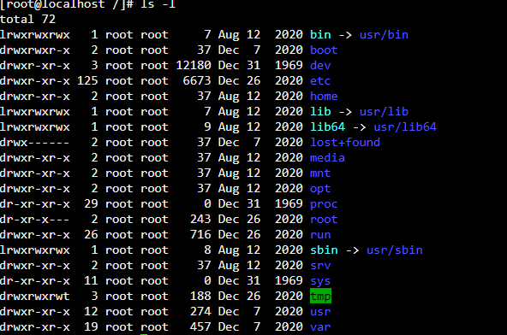

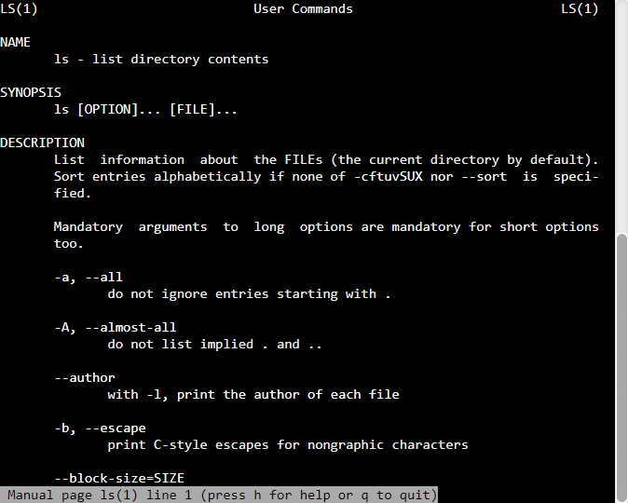Command 5 :- man

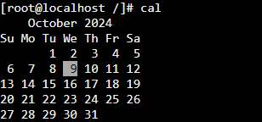Command 6 :- cal

Command 7 :- date

Command 8 :- echo

Command 9 :- cat

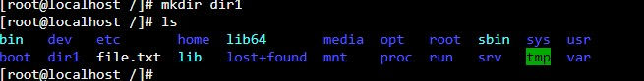Command 10 :- mkdir

Command 11 :- cmp

Command 12 :- comm

Command 13 :- diff



Command 14 :- head

Command 15 :- tail

Command 16 :- chown username file

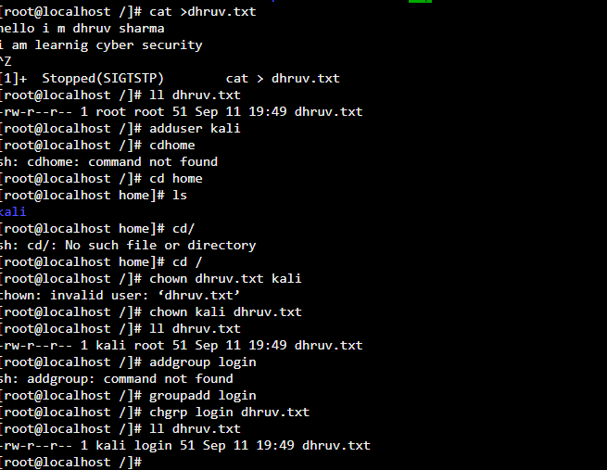 chgrp username file

Command 17 :- chmod

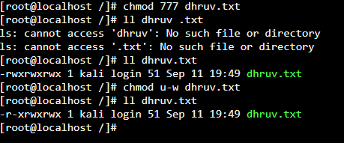

Command 18 :- gzip

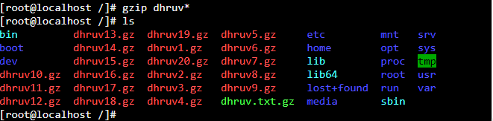 gunzip

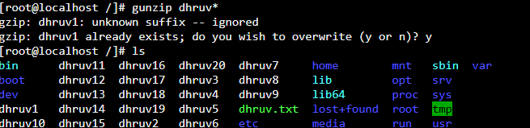

**Command 19:- tar**

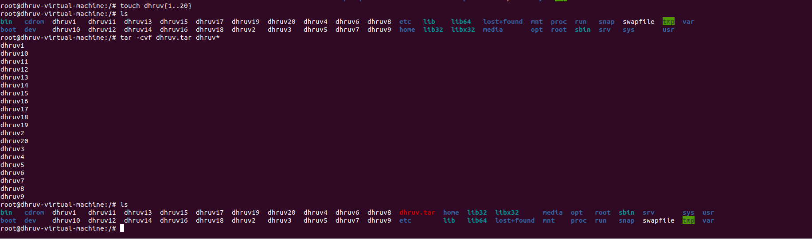

**Command 20:- pr**

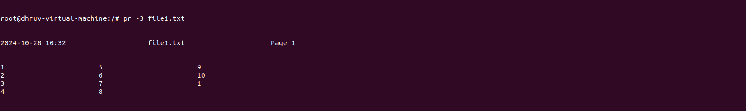

**Command 21:- cut**

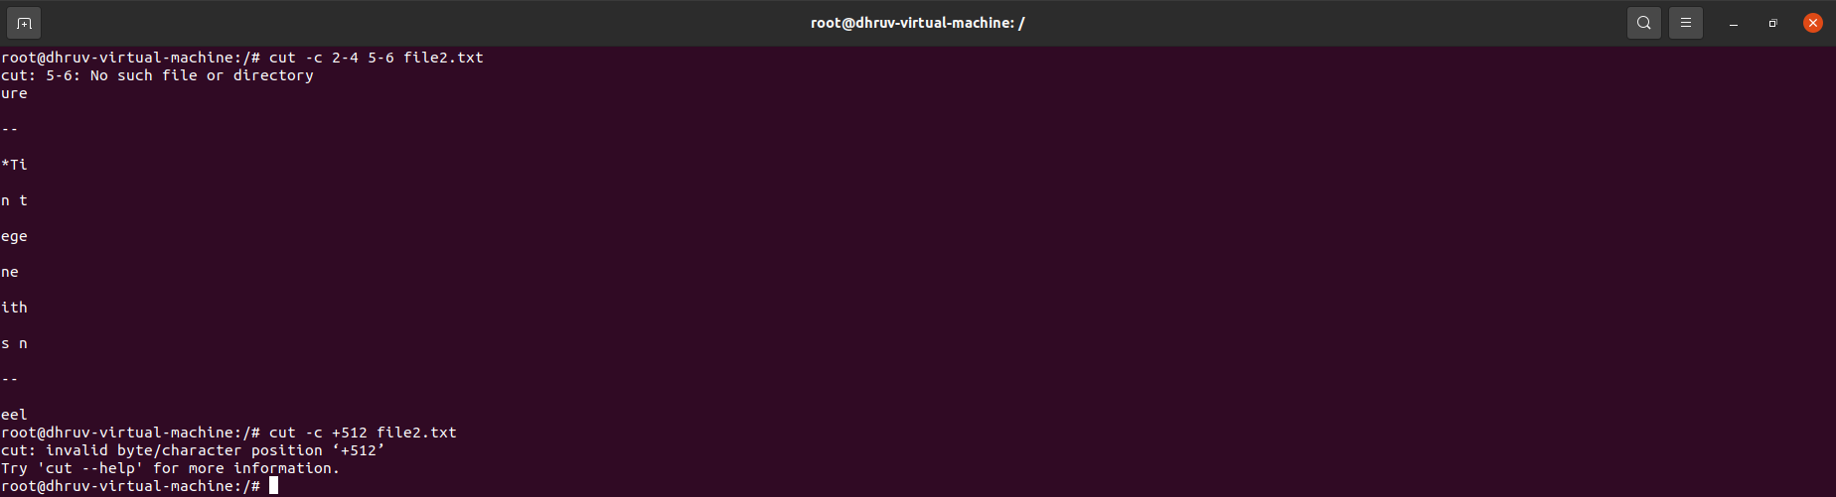

**Command 22:- paste**

**Command 23:- sort**

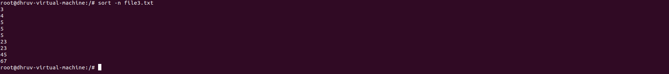

**Command 24:- uniq**

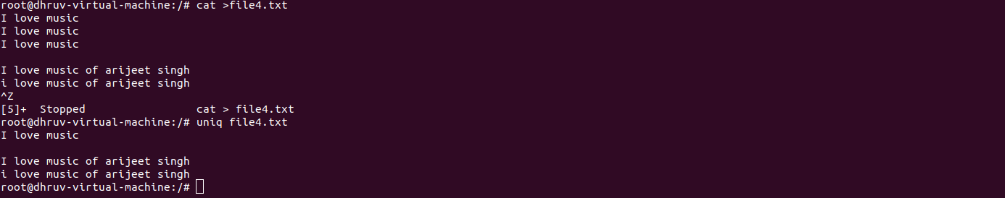

**Command 25:- tr**

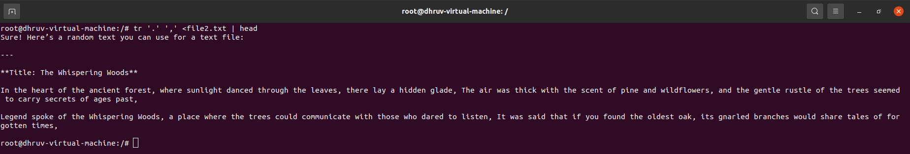

**Command 26:- ps**

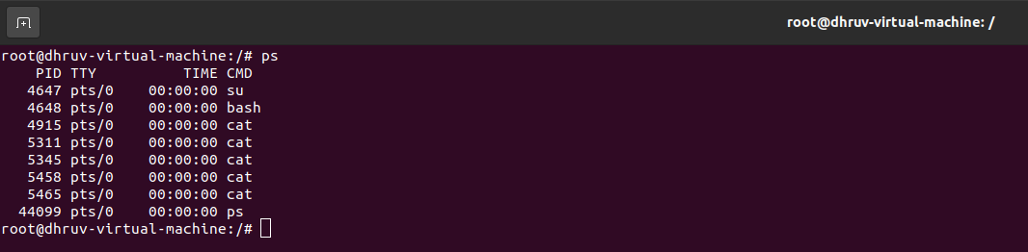

**Command 27:- &**

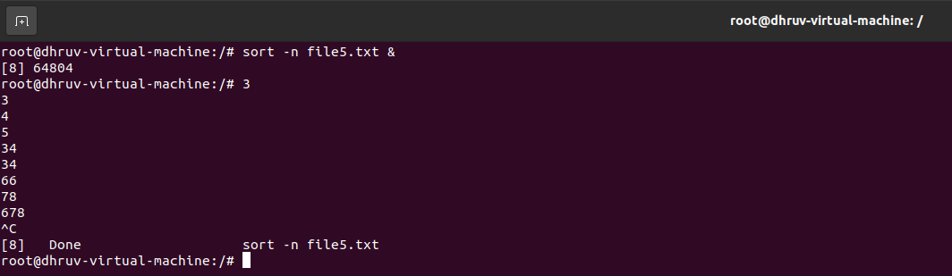

**Command 28:- nohup**

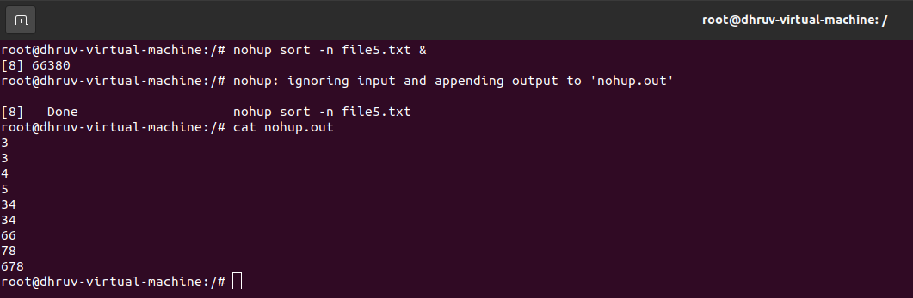

**Command 29:- nice**

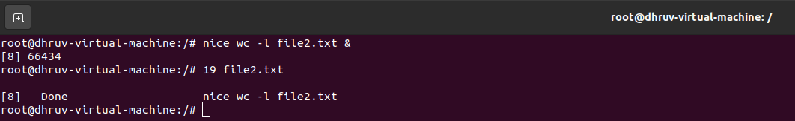

**Command 30:- kill**

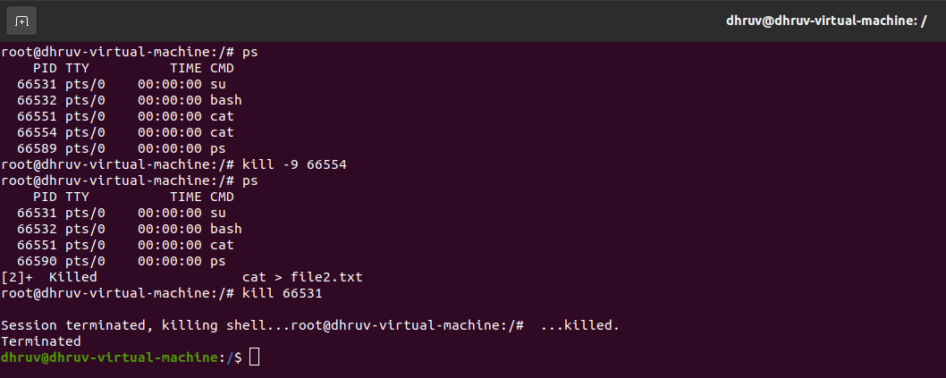

**Command 31:- jobs**

